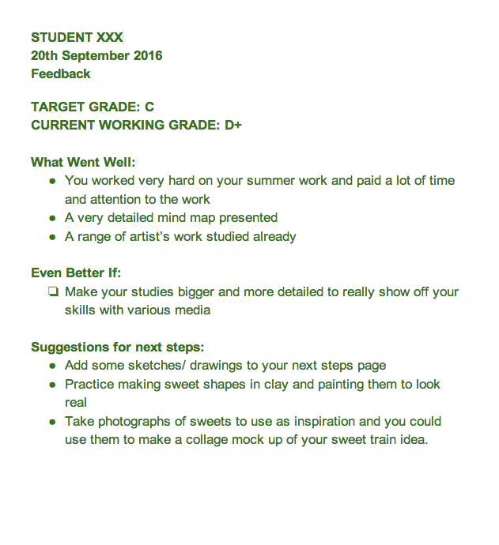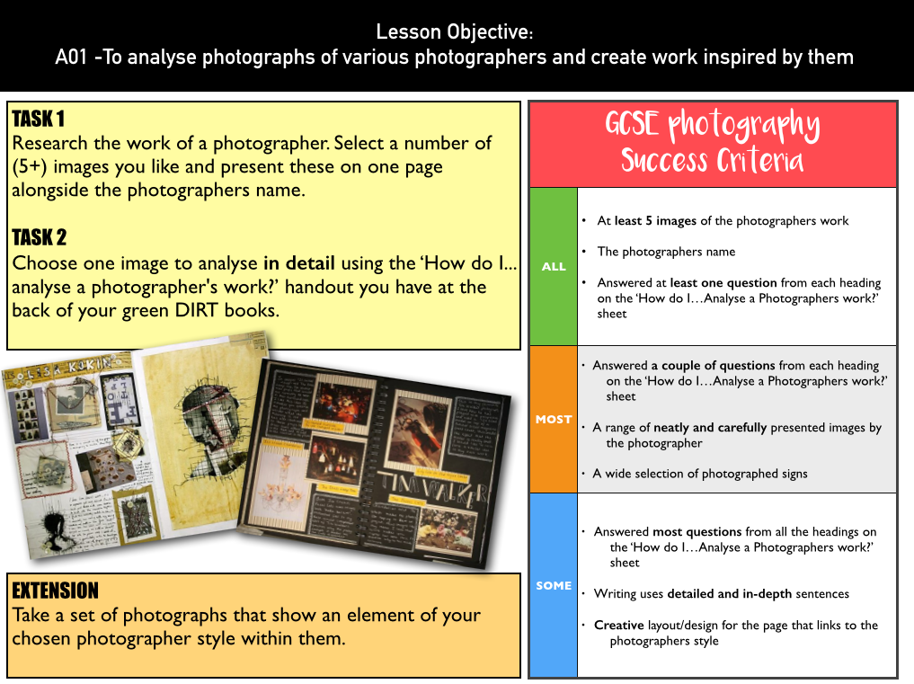

NAME: Lily Prosser GCSE PHOTOGRAPHY Year 9

You will be given targets to improve your work each time your work is marked either as a formal assessment or informal feedback shared on your blog page.

* You will be given feedback through WWW and EBI/NEXT STEPS
* RAG analysis

You can action these targets in the lesson, at home or during the catch up session after school, it is important to do this to improve your overall grade.

|  |  |  |
| --- | --- | --- |
|  | Target Grade | Working at Grade |
| Autumn 1 |  |  |
| Autumn 2 |  |  |
| Spring 1 |  |  |
| Spring 2 |  |  |
| Summer 1 |  |  |
| Summer 2 |  |  |



NAME: GCSE PHOTOGRAPHY – WWW/EBI student assessment

|  |  |  |  |  |
| --- | --- | --- | --- | --- |
| **TASK:**  **The basics**  **DATE:**  **October 20** | **WWW: I think that the artist investigations I done went well. As well as my photos that I’ve taken.**  **EBI: It would be better if, I display a clearer definition of key words.**  **NEXT STEPS: To write more detailed definitions of key words.** | **AO?**  **A02** | **RAG123**  **Student assessment**  **1** | **Achieved MISS S** |
| **TASK**  **DATE** | **WWW:**  **EBI:**  **NEXT STEPS:** | **AO?** | **RAG123** | **Achieved MISS S** |
| **TASK**  **DATE** | **WWW:**  **EBI:**  **NEXT STEPS:** | **AO?** | **RAG123** | **Achieved Miss S** |
| **TASK**  **DATE** | **WWW:**  **EBI:**  **NEXT STEPS:** | **AO?** | **RAG123** | **Achieved MISS S** |
| **TASK**  **DATE** | **WWW:**  **EBI:**  **NEXT STEPS:** | **AO?** | **RAG123** | **Achieved MISS S** |
| **TASK**  **DATE** | **WWW:**  **EBI:**  **NEXT STEPS:** | **AO?** | **RAG123** | **Achieved**  **MISS S** |
| **TASK**  **DATE** | **WWW:**  **EBI:**  **NEXT STEPS:** | **AO?** | **RAG123** | **Achieved MISS S** |
|  |  |  |  |  |



AO1 = Research

AO2 = Experimenting

AO3 = Recording

AO4 = Final Work

GCSE PHOTOGRAPHY - RAG123

|  |  |
| --- | --- |
| Marking Guide - Student says: | Marking Guide - Miss Stevens Says: |
| I tried really hard this term  I avoided distractions  I tried to push my understanding/skills | Excellent amount of work created  Focused and all tasks |
| I mostly concentrated this term  I could have tried harder  I didn’t really push myself | Satisfactory amount of work created  Focused and on tasks for some of the  Lessons this term. |
| I really was not trying this term  I let things distract me from my learning  I will need to make up for it next lesson | Unsatisfactory amount of work  Not focused or off task for most of the term |
| 1 = I feel very confident with the skill/s I used today and could teach others  2 = I feel I have a good level of skill  3 = I am still developing this skill and might need some help | 1 = Excellent skill level demonstrated /  working above target level  2 = Good skill level demonstrated /  working at targeted level  3 = Skill still being developed /  Working below the target level |